

Workforce Race Equality Standard (WRES) Annual Report 2025

Definitions
- BME - Black and Minority Ethnic: At Sandwell and West Birmingham NHS Trust, we currently use the terminology BME Black and Minority Ethnic throughout this report in line with current terminology used in the WRES Mandated Standards. The data sets in this report compare the experience of Black and Minority Ethnic (BME) staff to White staff.
- NHS – National Health Service
- WRES - Workforce Race Equality Standard
- CPD – Continuous Professional Development

Introduction
The Workforce Race Equality Standard (WRES), implemented in 2016, is a nationally mandated standard aimed at improving workplace experiences and career progression for NHS staff from Black and Minority Ethnic backgrounds (BME). It consists of nine specific metrics that allow organisations to compare the experiences of employees from BME backgrounds with those of white staff, enabling the identification of disparities and supporting targeted improvement efforts.

This report outlines Sandwell and West Birmingham’s performance against the WRES metrics for 2025, highlighting key trends, areas of progress, and areas for improvement It provides a foundation for the actions required to advance racial equity across the Trust.
The data presented draws from the Electronic Staff Record (ESR) and the NHS Annual Staff Survey. As these sources use differing staff group terminology, variations in language are reflected in the report.

Metrics 5 to 8 are based on responses to the NHS Staff Survey, which in 2024 achieved
a 34 % response rate, which includes 39.93 % from staff who identify as Black and Minority Ethnic.

As of March 2025, the Trust employs approximately 7347 staff, with 45% who identify as being from a BME background. Additionally, the proportion of staff who have not disclosed their ethnicity has improved from 10% to 11% indicating improved data accuracy and improvements overall in our equality data collection and monitoring processes.

Executive Summary
At Sandwell and West Birmingham NHS Trust, we are dedicated to creating an inclusive culture where diversity is not only valued and supported but also integrated into every aspect of our organisation. We believe that a diverse and engaged workforce is vital for delivering high-quality, compassionate care for our diverse patient population.

Equality Diversity and Inclusion is also an integral part of our “With you all the way” staff experience and culture transformation journey . Our Trust EDI Plan incorporates key programmes of work set out within the People Plan that impact on EDI from a culture and staff experience perspective and also includes specific additional work programmes designed to help us get the basics right with regards to our EDI obligations , address consistent underperformance in workforce representation and set up the building blocks necessary to creating a strong foundation to build a more diverse and inclusive organisation .

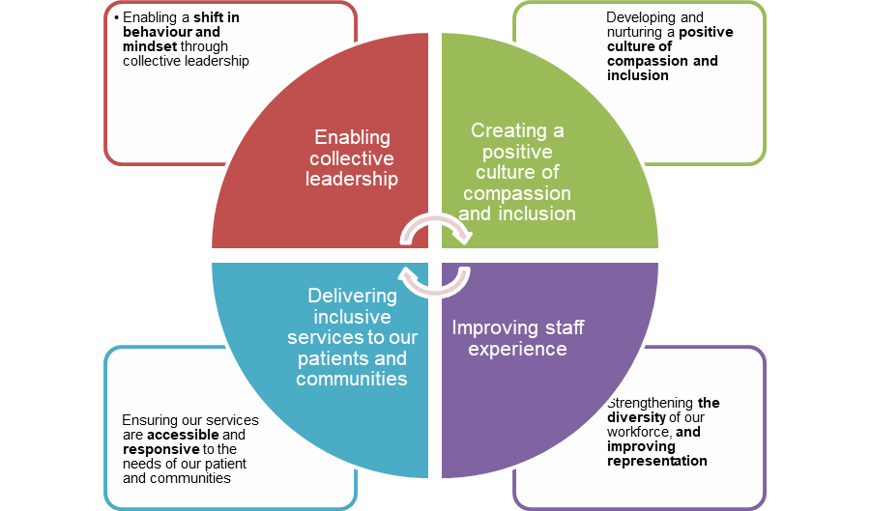

(Fig 1: Our SWB EDI Plan)

The 2025 Workforce Race Equality Standard (WRES) results highlight both progress and our areas for improvement. While there has been an increase in the representation of staff from BME backgrounds and improvements in the disciplinary and career progression indicators, it is acknowledged that inequalities persist in areas such as recruitment, harassment, bullying and abuse from members of the public, discrimination, access to development opportunities, and representation in senior leadership roles. However, work is ongoing to address these inequalities through our People Plan and EDI plan.

Key Highlights:
Improved measures in 2025

Key Highlights – 2025
- Workforce Representation: Staff from Black and Minority Ethnic (BME) backgrounds make up 45% of the workforce—above local community representation.
- Disciplinary Action: BME staff are 1.09 times more likely to face formal disciplinary processes than white staff, an improvement from 1.2 times the previous year.
- Career Progression: Staff reporting equal access to promotion increased from 44.5% to 46.4%.
- Ethnicity Declaration: Slight increase in staff disclosing ethnicity, improving data accuracy.

Declined Measures – 2025
- Recruitment: White applicants are 1.54 times more likely to be appointed from shortlisting (up from 1.2), attributed to a change in the way the recruitment data has been reported previously. The data source that will be used for future reporting purposes is TRAC rather than ESR.
- Development Access: White staff are 1.09 times more likely to access non-mandatory training/CPD (previously 0.89).
- Harassment from the Public: Reports increased slightly from 25% to 26%.
- Harassment from Staff: No change in reported rates.
- Discrimination: Rates remain unchanged but disproportionately affect BME staff (15% vs 6.3%).
- Board Representation: Remain unchanged at 25%

These findings emphasise the importance of continued action and efforts to deliver on our EDI commitments and our Trust EDI plan. Our With you all the way culture programme along with our refreshed EDI plan, is centred on inclusive leadership actions, delivering fair access to opportunities, and maintaining a zero-tolerance approach to discrimination and harassment. We are dedicated to fostering a workplace that is supportive, equitable, and inclusive for everyone who works at the Trust.

Shortly before the publication of the NHS Staff Survey 2023, a potential issue was identified affecting the data for several questions. To address this, statistical methods were applied to adjust the affected results, and the data for question 14 have been revised from what was previously published. As a result, the 2023 data comparisons differ from those in the earlier report. for further details, please refer to the Survey Coordination Centre's guidance: Survey documents related to conducting the survey | NHS Staff Survey

Annual Submission Measures
The Workforce Race Equality Standard is a set of nine specific measures which enable NHS organisations to compare the workplace and career experiences of staff from Black and Minority Ethnic backgrounds (BME) and White staff.

For this report, a more detailed analysis to inform our conclusions and action plans has been developed. The nine WRES indicators are as follows:

- Workforce Representation
- Recruitment
- Disciplinary
- Training and Continuing Professional Development (CPD)
- Harassment, Bullying and Abuse from Patients / Public
- Harassment, Bullying and Abuse from Staff
- Career Progression
- Discrimination
- Board Representation

Workforce Race Equality Standard Overview
Over the past five years, we have conducted an in-depth analysis of our Workforce Race Equality Standard (WRES) metrics. The chart below Table 1.0 presents a summary of our performance and highlights trends across all nine metrics from 2020 to 2025

Table 1.0.
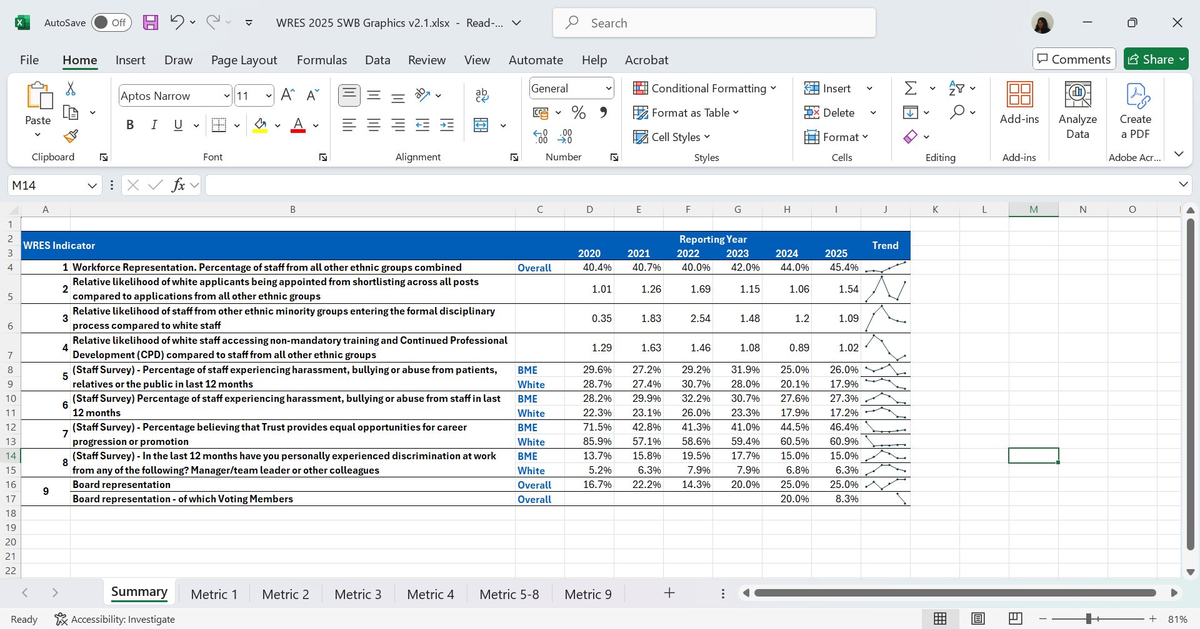

Note: Staff survey metrics are 1 year behind the submission year; the 2025 data shown in this table are 2024 staff survey metrics.

Metric 1 – Overall Representation

As of March 2025, data from the NHS Electronic Staff Record (ESR) shows that 45% of the Trust’s workforce identified as being from a BME background —an increase of 1% from the previous year. Sandwell and West Birmingham NHS Trust has experienced an improvement in workforce representation overall since 2020, alongside improvements in the number of staff choosing to disclose their ethnic background.

This trend suggests that more employees feel confident sharing their ethnicity. The work carried out recently by the Trust to directly employ staff from the local area (#More thanaJob employability programme) has resulted in improvements for workforce representation overall. The chart below (Table 1.1) provides details on workforce representation.

Table 1.1

Metric 1 data is split by clinical and non-clinical roles to highlight staff disparities and guide focused action. Clinical roles involve direct patient care with medical qualifications; non-clinical roles provide administrative and operational support. The tables below show ethnic representation by pay band, revealing distinct patterns for tailored interventions.

Metric 1 – Non-Clinical Banding Comparison 2024-2025
The data in Table 1.2 highlights patterns of inequality within the agenda for change pay scales, with BME staff being overrepresented in the lower pay scales when compared to colleagues from a non-BME background. For example, BME staff are over-represented in Bands 2 (Apprentices), 3,5, and 6, but decline sharply at senior levels, with only 22% of VSM roles being held by BME colleagues.

Although responses marked as ‘Not Stated/Unknown’ are few, the evident pattern indicates issues with progression that limit staff from BME backgrounds from securing higher-level posts and senior leadership positions. The data highlights the importance of the Trust continuing to implement focused, targeted measures to enhance equity in career development and leadership opportunities through its current Inclusive Recruitment workstream, ensuring inclusive promotion processes, and effectively supporting and retaining diverse talent across all levels.

Table 1.2

Metric 1 – Clinical Banding Comparison 2024 -2025

Analysis of Representation Across Clinical Bands:
The data in table 1.3 reveals a good representation of BME staff across clinical Bands 5 to 8a, with particularly high diversity at Band 6, where BME staff constitute up to 45% of the workforce. However, this level of representation sharply declines at senior leadership levels. Bands 8c, 8d, and 9, as well as Very Senior Manager (VSM) roles, are predominantly held by staff from white backgrounds. Notably, Band 9 includes only 20% BME representation, while VSM roles are exclusively occupied by white staff.
This disparity signals a significant progression gap, whereby BME clinical staff, despite being well-represented at operational levels, are not advancing proportionately into senior leadership positions.

To address this imbalance, focused work is ongoing as part of the existing Inclusive Talent Management and Resourcing Group workstream to:
- Strengthen inclusive career development pathways.
- Implement targeted succession planning that supports BME staff.
- Enhance access to leadership development opportunities.
- Ensure that progression processes are equitable, transparent, and accessible to all staff.
Creating a truly inclusive leadership pipeline is essential for achieving equity and ensuring that the clinical leadership reflects the diversity of the wider workforce and the communities served.

Table 1.3

Metric 2 – Relative likelihood of white applicants being appointed from shortlisting across all posts compared to ethnically diverse applicants
In 2025, the relative likelihood of applicants from Black and Minority Ethnic (BME) backgrounds being appointed from shortlisting was 1.54, an increase from 1.06 in 2024. While a score of 1.00 indicates parity between groups, this rise reflects a decline in equity for this indicator, suggesting that white applicants were less likely to be appointed than their BME counterparts at this stage.

Appointment rates further illustrate this disparity, with 13% of ethnic minority applicants being appointed, compared to 20% of white applicants.

It is important to note that for previous reporting years, data was sourced from ESR rather than TRAC. As a result, there are known anomalies with WRES Indicator 2. This issue will be addressed in the next WRES reporting cycle, with TRAC recruitment data used as the standard data source moving forward.
Table 2.0

The data highlights disparity in recruitment outcomes, highlighting a requirement to strengthen inclusive hiring practices and reduce bias. Work is ongoing through the Trust’s inclusive recruitment workstream to tackle and eliminate inequalities through the recruitment life cycle.

Metric 3 - The relative likelihood of ethnically diverse staff entering the formal disciplinary process compared to white staff
A relative likelihood score above 1.00 means that staff from BME backgrounds are more likely than white staff to enter the formal disciplinary process. In 2025, the score is 1.09, showing a slight improvement from 1.20 the previous year. While this indicates some progress, it still highlights that BME staff are more likely to face formal disciplinary action, highlighting potential bias and inconsistency in how policies are applied. Specifically, BME Staff were 0.4% more likely to enter the process compared to white staff. (0.3%) To address these disparities, a programme of work focused on embedding a just and restorative learning culture specifically focussed on reducing the number of disciplinary cases and reducing the disproportionate impact of our processes on BME staff is currently underway as part of our Trust “With you all the way” Culture Programme.

Table 3.0

Metric 4 - The relative likelihood of white staff accessing non–mandatory training and continuing professional development (CPD) compared to Black and Minority Ethic Staff
In 2024/25, white staff were 1.02 times more likely than Black and Minority Ethnic Staff to access non-mandatory training and CPD, up from 0.89 in 2023/24. A figure above 1.00 indicates greater access for white staff.

This is based on total course attendances among substantive staff, where individuals attending multiple sessions are counted multiple times. When using distinct headcount, counting each person only once, the figure rises slightly to 1.29.

National guidance does not mandate whether to use attendance or headcount. The Trust has traditionally reported attendances, though both methods yield similar outcomes. For example, someone attending two of three allyship sessions would count as two attendances but one headcount.

The Trust remains committed to addressing disparities in access to development and will continue to review its reporting approach in line with best practice.

Table 4.0

Metric 5 - The percentage of staff experiencing harassment, bullying or abuse from patients, relatives or the public
The proportion of staff reporting harassment, bullying, or abuse from patients, relatives, or the public in the past 12 months has increased slightly among staff from Black and Minority Ethnic backgrounds, rising from 25% in 2024 to 26% in 2025, a percentage increase of 1% from the previous year.

In contrast, the reporting rate for staff from white backgrounds has decreased from 20.1% to 17.9% in 2025

Staff from BME backgrounds accounted for 39.93% of respondents for the 2024 staff survey. surveys in 2024

Table 5.0: Workforce Race Equality Data for Metric 5 from 2020 to 2024.
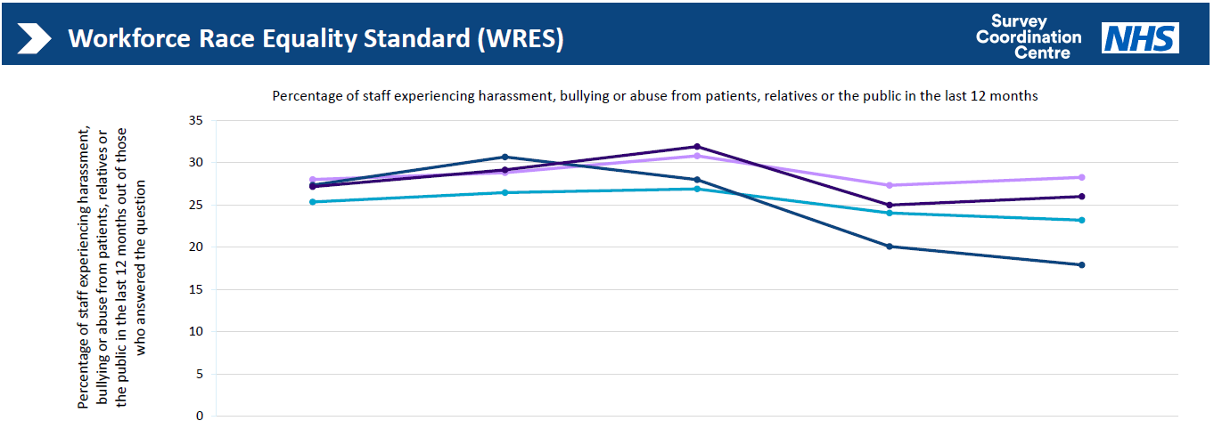
Staff group | 2020 | 2021 | 2022 | 2023 | 2024
White staff SWB | 27.36% | 30.69% | 27.99% | 20.10% | 17.92%
All other ethnic groups SWB | 27.16% | 29.15% | 31.92% | 25.00% | 26.01%
White staff average | 25.36% | 26.47% | 26.91% | 24.05% | 23.21%
All other ethnic groups' average | 28.01% | 28.84% | 30.82% | 27.34% | 28.27%
White staff responses | 1389 | 1603 | 1561 | 1293 | 1574
All other ethnic group responses | 751 | 1005 | 1106 | 820 | 1088

Metric 6 - The percentage of staff who experienced harassment, bullying or abuse from other staff
The percentage of staff from ethnically diverse backgrounds reporting harassment, bullying, or abuse from colleagues in the past 12 months has remained static. In 2024, the reporting rate was 27.6%, and in 2025, it was 27.3%, representing a 0.3% reduction compared to the previous year. For staff from white backgrounds, the rate has improved slightly, which was 17.93 % in 2024 and stands at 17.23%, reflecting a smaller decrease in percentage points since 2024.

Table 6.0: Workforce Race Equality Data for Metric 6 from 2020 to 2024.

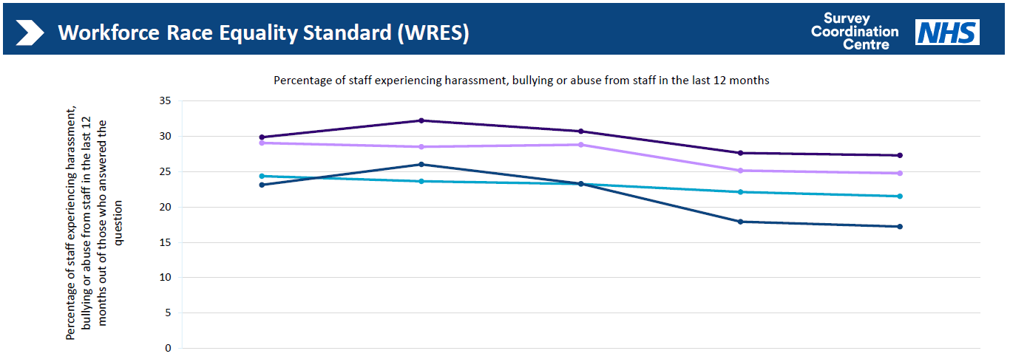
Staff group | 2020 | 2021 | 2022 | 2023 | 2024
White staff SWB | 23.14% | 26.03% | 23.30% | 17.93% | 17.23%
All other ethnic groups SWB | 29.88% | 32.24% | 30.72% | 27.64% | 27.31%
White staff average | 24.37% | 23.65% | 23.25% | 22.12% | 21.53%
All other ethnic groups' average | 29.07% | 28.53% | 28.81% | 25.16% | 24.78%
White staff responses | 1396 | 1598 | 1562 | 1288 | 1573
All other ethnic group responses | 753 | 1005 | 1110 | 818 | 1091
Positive progress is being made in reducing internal bullying through the implementation of the Trust’s With you all the way Culture Programme; however, continued focus is needed to sustain improvement.

Metric 7 - The percentage of staff who believed that the trust provided equal opportunities for career progression or promotion
The percentage of staff from BME backgrounds who believe the Trust provides equal opportunities for career progression or promotion has improved since the previous reporting year, from 44.6% in 2024 to 46.4% in 2025. It is acknowledged that a disparity still exists between staff from BME backgrounds and staff from white backgrounds, with a gap of (60.89 % vs. 46.4%) concerning staff experience. However, survey responses from staff from BME backgrounds have shown a notable improvement over the past five years, indicating a gradual positive shift in staff engagement levels.

Table 7.0: Workforce Race Equality Data for Metric 7 from 2020 to 2024.
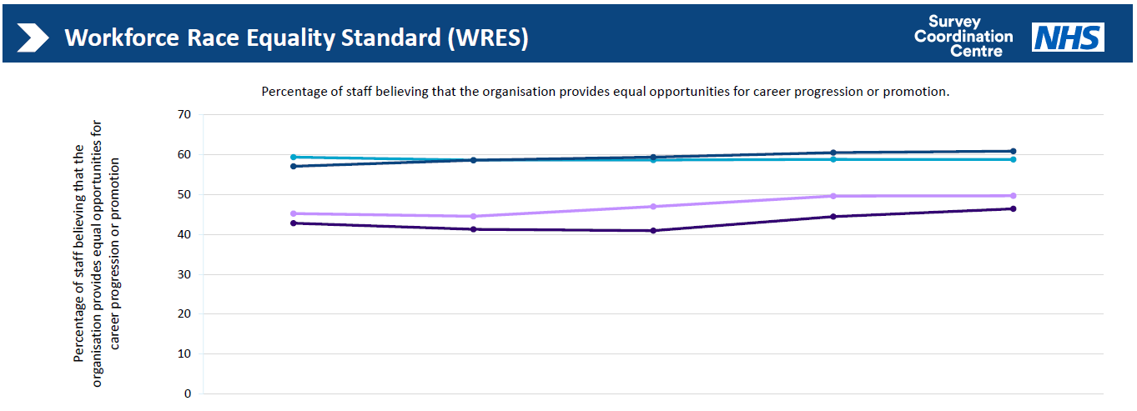
Staff group | 2020 | 2021 | 2022 | 2023 | 2024
White staff SWB | 57.09% | 58.61% | 59.40% | 60.54% | 60.89%
All other ethnic groups SWB | 42.82% | 41.29% | 40.95% | 44.46% | 46.43%
White staff average | 59.39% | 58.64% | 58.65% | 58.84% | 58.82%
All other ethnic groups' average | 45.24% | 44.56% | 47.00% | 49.64% | 49.70%
White staff responses | 1417 | 1556 | 1542 | 1343 | 1570
All other ethnic group responses | 780 | 976 | 1094 | 902 | 1092

The percentage gap between white staff and BME staff for this indicator indicates disparities with career progression and promotion; however, a focused programme of work through the Inclusive Talent Management and Resourcing Workstream is currently underway to support improvements.

Metric 8 - The percentage of staff who personally experienced discrimination at work from a manager, team leader or other colleagues
The percentage of staff reporting discrimination from a manager, team leader, or other colleagues has remained static since the previous reporting year. Among staff from BME backgrounds, the rate stands at 15.0% for 2024, while for staff from white backgrounds, it is 6.3% in 2025, reflecting the disparity between the two groups.

Table 8.0
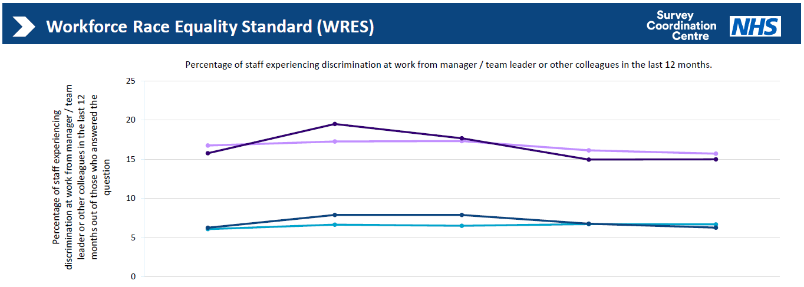

Staff group | 2020 | 2021 | 2022 | 2023 | 2024
White staff SWB | 6.27% | 7.90% | 7.89% | 6.78% | 6.28%
All other ethnic groups SWB | 15.78% | 19.51% | 17.69% | 14.97% | 15.00%
White staff average | 6.09% | 6.67% | 6.52% | 6.73% | 6.69%
All other ethnic groups' average | 16.77% | 17.28% | 17.33% | 16.14% | 15.72%
White staff responses | 1308 | 1569 | 1533 | 1342 | 1560
All other ethnic group responses | 716 | 979 | 1091 | 902 | 1073

The proportion of BME Board members at Sandwell and West Birmingham NHS Trust has remained unchanged at 25% since the last reporting period. However, the percentage of BME Board members with voting rights has decreased—from 20% in 2024 to 8% in 2025. Efforts are ongoing through the Inclusive Talent Management and Resourcing Group to nurture internal talent and enhance representation at senior leadership levels.

Metric 9 - Percentage difference between the organisations’ Board membership and its overall workforce disaggregated:
The proportion of BME Board members at Sandwell and West Birmingham NHS Trust has remained unchanged at 25% since the last reporting period. However, the percentage of BME Board members with voting rights has decreased—from 20% in 2024 to 8% in 2025. Efforts are ongoing through the Inclusive Talent Management and Resourcing Group to nurture internal talent and enhance representation at senior leadership levels.

Table 10

Conclusion

Over the past 12 months, the Trust has made progress in advancing its Equality, Diversity, and Inclusion (EDI) agenda through the effective implementation of the EDI plan and our With you all the way culture programme. Key achievements include:
- Race Equality: The Trust signed up to the Race Code and successfully attained the Race Code Quality Mark in May 2024.
- Inclusion Benchmarking: As a member of the Employers Network for Equality & Inclusion (ENEI), the Trust participated in the Talent Inclusion & Diversity Evaluation (TIDE) and was awarded Gold Status, the highest level of recognition.
- Disability Inclusion: The Trust achieved Disability Confident Employer Level 2 status in July 2024.
- Sector Collaboration: Completion of the NHS Employers’ Diversity in Health and Care Partners 2023/2024 programme.

While positive shifts have been observed in some Workforce Race Equality Standard (WRES) indicators, we acknowledge that further sustained efforts are required to improve the experience of staff from Black and Minority Ethnic (BME) backgrounds and to embed a consistently inclusive and supportive workplace culture.

Looking ahead to 2025/26, the Trust People Committee in March agreed to focus on

The delivery of the following People Priorities for 2025/26
- Improve Staff Engagement Score
- Deliver sustained improvements across all NHS People Promises
- Increase Representational Leadership
- Implement national EDI high impact actions
- Drive further improvements in the Trust’s WRES and WDES outcomes
- Optimise Workforce Productivity

These priorities are being delivered at 4 levels (Fig1) : (1) Leadership (2) Teams (3) Individuals and (4) Organisation wide:
- Leadership: Strengthen leadership capability and accountability.
- Teams: Build high performing, engaged teams.
- Individuals: Empower colleagues to own and shape their experience.
- Organisation-wide: Systematically embed improvements across policies, systems, and culture.
(Figure 2 )
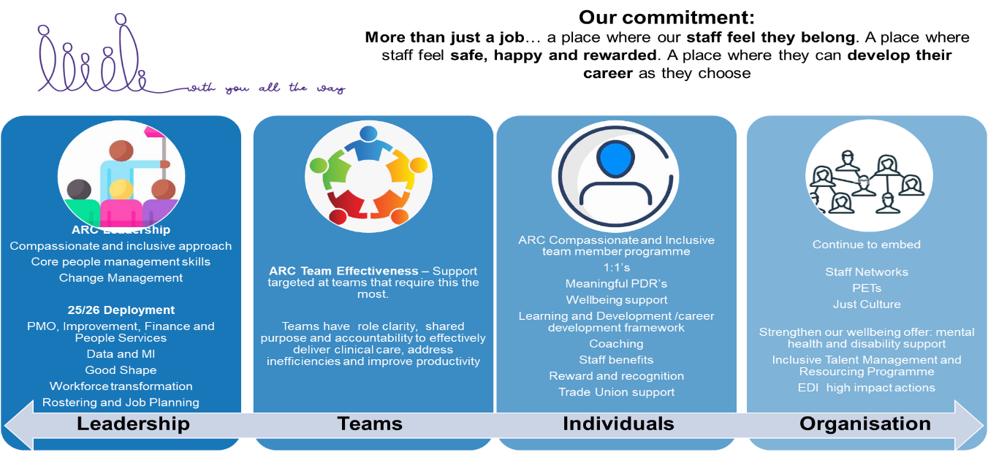

We will through this programme of work also continue to embed the following Four high-impact actions introduced in 2024 to drive further progress:
- Empower, equip, and enable Staff Networks
- Optimise the role and function of the EDI Team within the Trust
- Deliver and embed a robust framework for inclusive recruitment
- Launch a SWB Inclusive Talent Management Programme

