

Workforce Disability Equality Standard 2025

Definitions
- NHS – National Health Service
- AfC – Agenda for Change
- LTC – Long-term condition
- WDES – Workforce Disability Equality Standard

Introduction
Workforce Disability Equality Standard (WDES) Overview

Launched in 2019, the Workforce Disability Equality Standard (WDES) aims to improve workplace experiences and career opportunities for staff with disabilities across the NHS.

The WDES consists of ten specific measures (metrics) that enable Trusts to compare the experiences of disabled and non-disabled staff. These comparisons inform action plans and allow organisations to track progress in advancing disability equality.

Commissioned by the Equality and Diversity Council and mandated through the NHS Standard Contract, the WDES provides a framework for meaningful change.
Metrics 2 and 3 are calculated using a “times more likely” formula, which assesses disparities between disabled and non-disabled staff. Metrics 5, 6, 7, 8, and 9a are based on data from the NHS Staff Survey. Our Trust conducted a full staff survey in 2024, with a 34% participation rate.

A key challenge in disability monitoring across the NHS is the inconsistency in how disability is defined. The definitions used in the NHS Electronic Staff Record (ESR), NHS Staff Survey, and NHS Jobs differ from one another, and the legal definition outlined in the Equality Act 2010. Efforts are ongoing to align these definitions and introduce a unified, system-wide disability question.

At Sandwell and West Birmingham NHS Trust, we employ around 7437 staff. According to ESR data, 4.8% of staff have declared a disability. However, 18% staff have not disclosed their disability status. In contrast, the 2024 Staff Survey indicates that 23.33% of respondents identify as having a disability or long-term condition—an increase of 0.69% from 2023. This discrepancy highlights the limitations of ESR data and the need to encourage staff to update their records. This is a national challenge, not unique to our Trust.

This report highlights key focus areas and provides direction for targeted actions. It has been instrumental in guiding development efforts in previous years.

Executive Summary
At Sandwell and West Birmingham NHS Trust, we are dedicated to creating an inclusive and supportive environment where all staff – including those with disabilities or long-term conditions – feel valued, empowered, and able to thrive. This commitment is fundamental to delivering high-quality patient care and developing a resilient, innovative workforce.

Equality, Diversity, and Inclusion (EDI) are central to our “With You All the Way” staff experience and culture transformation journey. Our Trust EDI Plan aligns with key initiatives outlined in the People Plan, focusing on how EDI influences both culture and staff experience. In addition to these core programmes, the plan includes targeted actions to ensure we meet our EDI responsibilities, tackle persistent underrepresentation in our workforce, and lay the groundwork for building a more diverse and inclusive organisation.

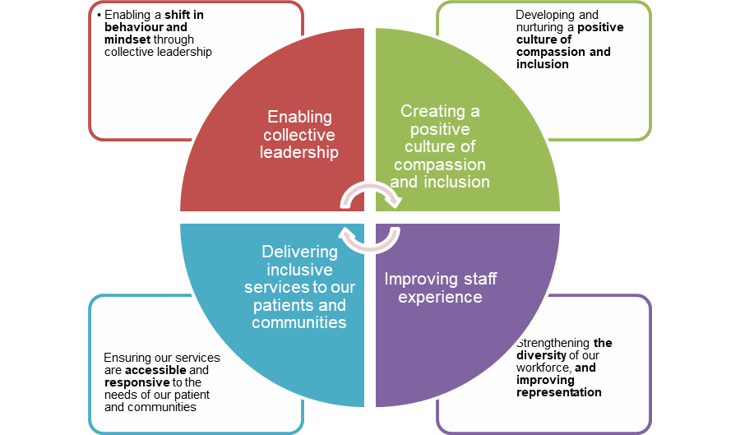

Fig 1: Our SWB EDI Plan

The 2025 Workforce Disability Equality Standard (WDES) results highlight both encouraging progress and areas where continued focus is essential. We have made strides in increasing disability declaration rates, improving staff experience with career progression and promotion opportunities and engagement scores, enhancing access to reasonable adjustments and improving scores for recruitment. However, challenges remain – particularly in addressing disparities in staff experience related to harassment, bullying and abuse and feeling valued in the workplace.

We recognise that sustained change requires ongoing engagement, accountability, and action. We remain committed to listening to our staff, learning from their experiences, and building a workplace where equity, respect, and opportunity are at the heart of everything we do.

Key Highlights from 2025:
- Workforce Representation:
4.8% of staff have declared a disability on the Electronic Staff Record (ESR), up from 4.0% in 2024. However, 18% of staff have not disclosed their status, highlighting the ongoing need to build awareness and trust across the workforce.
- Recruitment:
The relative likelihood of appointment for applicants with a disability improved slightly from 1.3 to 1.06. Nonetheless, a gap remains, with a 14.2% appointment rate for disabled applicants compared to 15.1% for non-disabled applicants.
- Capability Process:
For previous years' reporting, there were some challenges in the way data was collated due to issues with limited disability data held by the Trust. For the 2024 2025 reporting year, only one employee entered the formal capability process, which has skewed the data: In 2025 staff with disabilities were 3.00 times more likely to enter this process. However, in absolute terms, this involved only 0.1% of disabled staff and 0.1% of non-disabled staff.
- Harassment and Bullying:
Staff with long-term conditions continue to experience higher rates of bullying and abuse—particularly from patients and colleagues—than their non-disabled peers. Encouragingly, there have been improvements with the percentage of staff experiencing bullying and harassment from their line managers
- Career Progression:
52% of staff with a long-term condition believe they have equal opportunities for progression, reducing the gap with non-disabled colleagues to 3.66
- Presenteeism:
The proportion of staff with long-term conditions who felt pressured to work while unwell dropped to 27.9% from 34.7%, indicating progress in wellbeing support.
- Feeling Valued:
Only 33.6% of staff with long-term conditions feel valued by the organisation, compared to 46.7% of non-disabled staff. This disparity remains a key area of concern.
- Reasonable Adjustments:
71.9% of staff with long-term conditions reported receiving reasonable adjustments, an improvement from the previous year which was 68.9%
- Board Representation:
0% of board members declared a disability in 2025. This has remained static since the previous reporting year.

These insights reinforce the need for sustained focused efforts. Our With you all the way Culture programme and refreshed EDI priorities aligned to our WDES plan prioritises inclusive leadership, fair recruitment and career development, psychological safety, and a zero-tolerance stance on discrimination and harassment.

We remain committed to fostering a workplace where every individual—regardless of disability or health condition—can thrive, feel valued, and contribute meaningfully to our organisation.

Shortly before the publication of the NHS Staff Survey 2023, a potential issue was identified affecting the data for certain questions. To address this, statistical methods were applied to adjust the affected results. As a result, the data for Question 14 have been revised from what was previously released. This means that comparisons involving the 2023 data may differ from those in the earlier published report. For further details, please refer to the Survey Coordination Centre’s guidance: Survey documents related to conducting the survey | NHS Staff Survey.

Annual Submission Measures
The Workforce Disability Equality Standard (WDES) comprises ten specific metrics designed to help NHS organisations compare the workplace experiences and career progression of disabled and non-disabled staff. While the WDES offers a high-level overview, we have conducted a more in-depth analysis to guide our conclusions and inform our action plans.

WDES Metrics:
- Representation in the workforce
- Recruitment practices
- Capability procedures
- Experiences of harassment, bullying, and abuse from patients/public, managers, and colleagues
- Opportunities for career progression
- Pressure to attend work despite ill health
- Feeling valued for contributions at work
- Availability of reasonable adjustments
- Overall staff engagement score
- Representation at Board level

Workforce Disability Equality Standard Overview
Over the past 5 years, we have undertaken a detailed analysis of our Workforce Disability Equality Standard metrics. The chart below summarises our performance and provides a trend analysis from 2020 to 2025 on all ten metrics.
Note: staff survey metrics are 1 year behind submission year; 2025 data shown in this table is 2024 staff survey metrics.
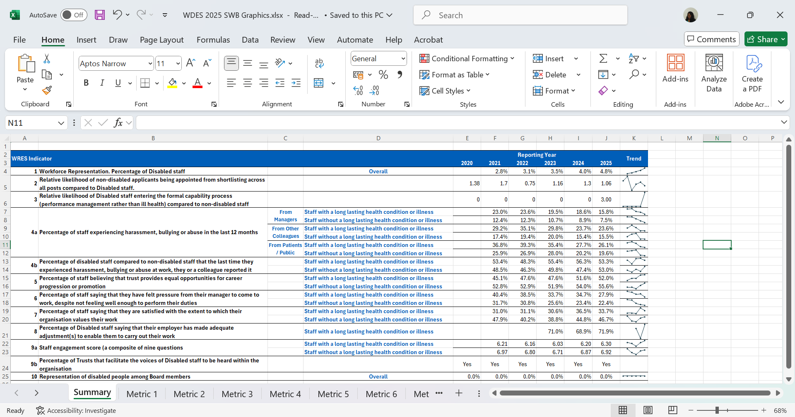

Metric 1 & 9 – Overall Disability Representation
Over the past three years, Sandwell and West Birmingham NHS Trust has consistently encouraged staff to declare disabilities. The chart below shows a steady rise in the number of employees choosing to disclose this information on the Electronic Staff Record, increasing from 2.8% in 2021 to 4.8% in 2025.

Metric 1 – Disability Representation Across the Workforce
Tracking disability representation across different pay bands within the NHS is essential to promoting fair career progression and equal opportunities for staff with disabilities. By monitoring this data, the organisation can uncover disparities, implement targeted support, and remove barriers that may hinder advancement at any level. This type of analysis plays a vital role in creating an inclusive and equitable workplace where all employees—regardless of disability—can access opportunities for growth and development.
The graph below illustrates how staff with disabilities are distributed across the various pay bands at Sandwell and West Birmingham NHS Trust

The data highlights that disabled colleagues are evenly represented in the AFC pay scales 2-8c. While disability representation is more visible in the lower pay bands, it decreases significantly at senior levels, a situation worsened by many 'Not Stated/Unknown' responses among higher grades.
This pattern suggests either a barrier to career progression for staff with disabilities or a hesitancy to disclose disability status as employees advance into senior roles. It underscores a requirement for focused efforts to increase disclosure rates and promote fairness in career development and leadership opportunities, ensuring that promotion processes are genuinely inclusive and that talented individuals are supported and retained at all levels of the organisation.

Metric 2 – Relative likelihood of non-disabled staff being appointed from shortlisting compared to Disabled staff
Values | Non-Disabled | Disabled | Unknown / Not stated | Grand Total
Number of Shortlisted Applicants | 7175 | 479 | 184 | 7838
Number Appointed from Shortlisting | 1080 | 68 | 43 | 1191
Relative Likelihood of appointment from shortlisting | 15.1% | 14.2% | 23.4% | 15.2%
Relative likelihood of non-disabled staff being appointed from shortlisting compared to Disabled staff | 1.06
A value of 1.0 indicates equal rates of appointment. The relative likelihood of an applicant with a disability being appointed after shortlisting is 1.06, slightly improving from 1.3 in 2024 and 1.16 in 2023. Of the applicants with disabilities, 14% were appointed following shortlisting, compared to 15% without a disability.

Metric 3 - The relative likelihood of disabled staff entering the formal capability process compared to non-disabled staff
This metric is typically expressed as a ‘times more likely’ figure, comparing the likelihood of staff with disabilities entering the formal capability process against those without disabilities.

In 2024, the metric was affected by a small number of staff entering the formal capability process, which skewed the results. To provide clearer insight, we’ve converted the data into percentages: 0.1 of staff with disabilities and 0.1% of staff without disabilities who entered the capability procedure.

Metric 4a - Percentage of staff experiencing harassment, bullying or abuse from patients/service users, their relatives or the public.
In 2024, 26.07% of staff with a long-term condition or illness reported experiencing harassment, bullying, or abuse from patients or the public—a figure which has improved slightly from the previous year. By contrast, 19% of staff without a long-term condition or illness reported similar experiences.

Staff group | 2020 | 2021 | 2022 | 2023 | 2024
Staff with a LTC or illness SWBH | 36.79% | 39.27% | 35.36% | 27.65% | 26.07%
Staff without a LTC or illness SWBH | 25.89% | 26.91% | 27.96% | 20.22% | 19.59%
Staff with a LTC or illness average | 30.86% | 32.43% | 32.98% | 29.83% | 29.37%
Staff without a LTC or illness average | 24.53% | 25.19% | 21.16% | 23.11% | 22.71%
Staff with a LTC or illness responses | 511 | 629 | 591 | 492 | 633
Staff without a LTC or Illness responses | 2109 | 2155 | 2178 | 1584 | 2032

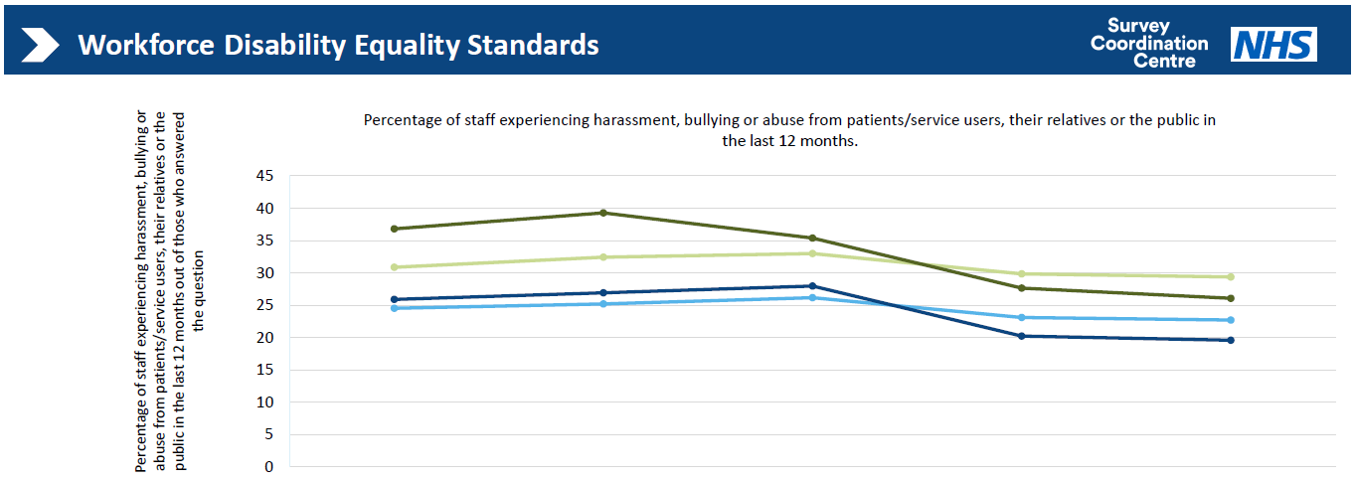

Metric 4a - Percentage of staff experiencing harassment, bullying or abuse from managers
In 2024, 15.8% of staff with a long-term condition or illness reported experiencing harassment, bullying, or abuse from managers, representing an improvement from the previous year, which was 18.6%

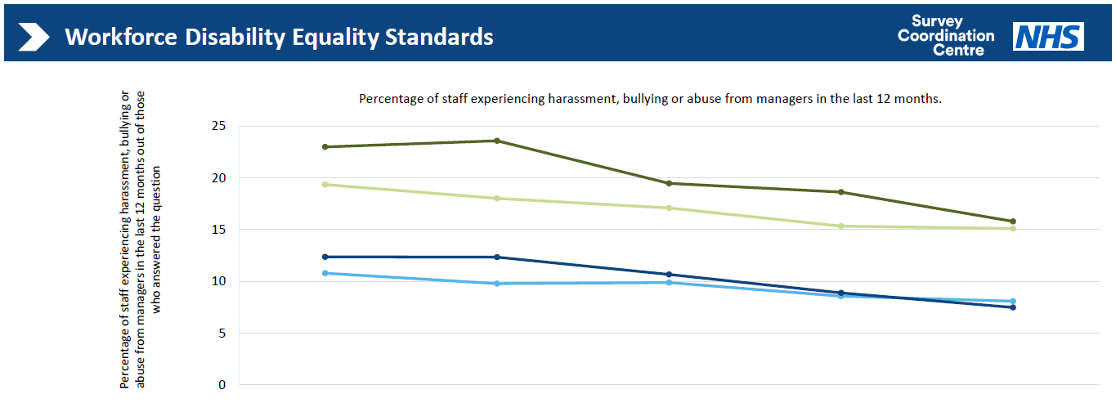

Staff group | 2020 | 2021 | 2022 | 2023 | 2024
Staff with a LTC or illness SWBH | 22.99% | 23.58% | 19.45% | 18.62% | 15.79%
Staff without a LTC or illness SWBH | 12.36% | 12.34% | 10.66% | 8.88% | 7.47%
Staff with a LTC or illness average | 19.35% | 18.00% | 17.09% | 15.33% | 15.10%
Staff without a LTC or illness average | 10.78% | 9.77% | 9.88% | 8.56% | 8.08%
Staff with a LTC or illness responses | 509 | 615 | 586 | 485 | 627
Staff without a LTC or Illness responses | 2103 | 2140 | 2166 | 1578 | 2021

Metric 4 - Percentage of staff experiencing harassment, bullying or abuse from other colleagues
In 2024, 23.63% of staff with a long-term condition or illness reported experiencing harassment, bullying, or abuse from colleagues, maintaining the same level as the previous year. In comparison, 15% of staff without a long-term condition or illness faced similar incidents, which remained unchanged from 2023.

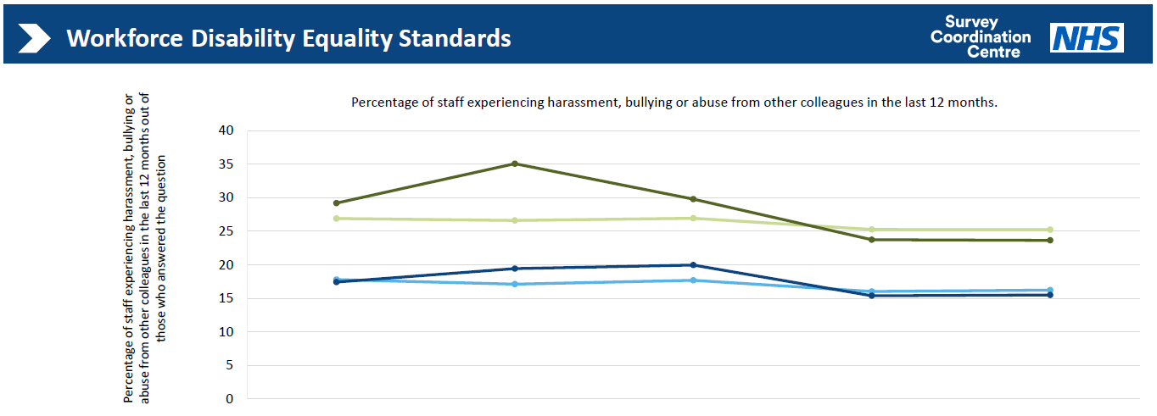

Table 3: Workforce Disability Equality Data for Metric 4 from 2020 to 2024.
Staff group | 2020 | 2021 | 2022 | 2023 | 2024
Staff with a LTC or illness SWBH | 29.19% | 35.07% | 29.79% | 23.73% | 23.63%
Staff without a LTC or illness SWBH | 17.42% | 19.43% | 19.95% | 15.37% | 15.48%
Staff with a LTC or illness average | 26.89% | 26.60% | 26.93% | 25.26% | 25.24%
Staff without a LTC or illness average | 17.79% | 17.11% | 17.67% | 16.01% | 16.22%
Staff with a LTC or illness responses | 507 | 613 | 584 | 482 | 622
Staff without a LTC or Illness responses | 2084 | 2115 | 2160 | 1554 | 2009

Metric 4b - Percentage of staff saying that the last time they experienced harassment, bullying or abuse at work, and they or a colleague reported it
In 2024, 53.3% of staff with a long-term condition or illness reported that they had reported the last incident of harassment, bullying, or abuse they experienced at work, reflecting a decline. In 2023, it was 56.25%.

Table 4: Workforce Disability Equality Data for Metric 4 from 2020 to 2024.
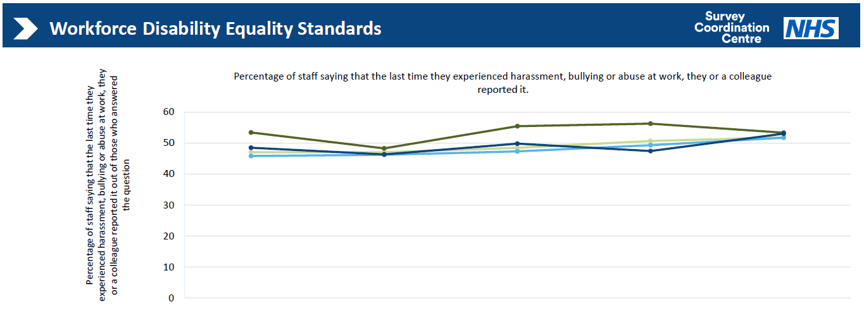
Staff group | 2020 | 2021 | 2022 | 2023 | 2024
Staff with a LTC or illness SWBH | 53.39% | 48.28% | 55.44% | 56.25% | 53.33%
Staff without a LTC or illness SWBH | 48.49% | 46.33% | 49.80% | 47.41% | 53.02%
Staff with a LTC or illness average | 47.01% | 47.03% | 48.43% | 50.64% | 51.82%
Staff without a LTC or illness average | 45.80% | 46.20% | 47.30% | 49.31% | 51.71%
Staff with a LTC or illness responses | 251 | 319 | 285 | 192 | 240
Staff without a LTC or Illness responses | 697 | 762 | 745 | 428 | 530

Metric 5 - Percentage of staff believing that their organisation provides equal opportunities for career progression or promotion.
In 2024, there was a 0.41% improvement in perceptions of equal opportunities for career progression or promotion. 51.97 % of staff with a long-term condition or illness felt they had equal opportunities, compared to 55% of staff without a long-term condition or illness, narrowing the gap between colleagues with a disability and long-term health condition and those without.

Table 5: Workforce Disability Equality Data for Metric 5 from 2020 to 2024.

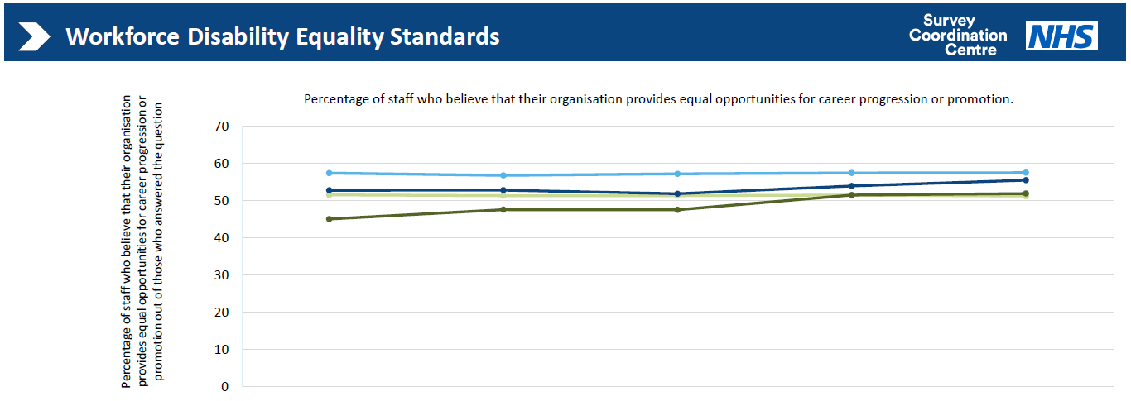

.
Staff group | 2020 | 2021 | 2022 | 2023 | 2024
Staff with a LTC or illness SWBH | 45.12% | 47.63% | 47.58% | 51.56% | 51.97%
Staff without a LTC or illness SWBH | 52.84% | 52.89% | 51.92% | 54.00% | 55.56%
Staff with a LTC or illness average | 51.61% | 51.41% | 51.39% | 51.54% | 51.30%
Staff without a LTC or illness average | 57.45% | 56.84% | 57.25% | 57.52% | 57.57%
Staff with a LTC or illness responses | 543 | 590 | 578 | 514 | 635
Staff without a LTC or Illness responses | 2199 | 1993 | 2138 | 1698 | 2032

Metric 6 - Percentage of staff who have felt pressure from their manager to come to work, despite not feeling well enough to perform their duties.
In the 2024 survey, 27.94% of staff with a long-term condition or illness reported experiencing presenteeism, a decrease from 34.68% in the previous year. In comparison, 22% of staff without a long-term condition or illness felt pressure from their manager to come to work despite not being well enough.
Table 6: Workforce Disability Equality Data for Metric 6 from 2020 to 2024
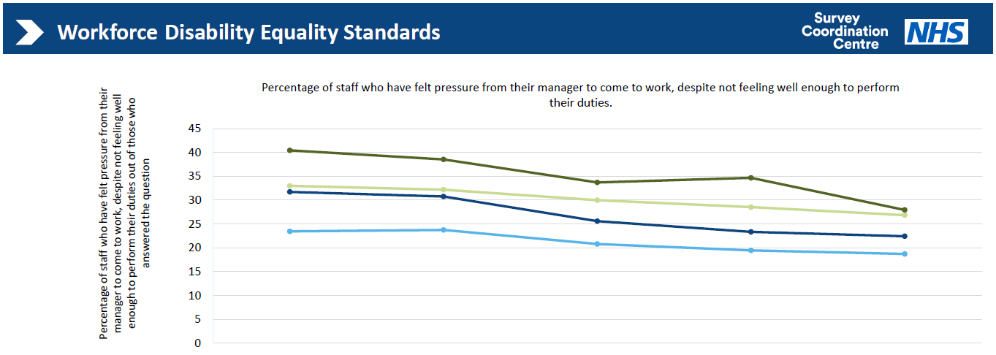

Staff group | 2020 | 2021 | 2022 | 2023 | 2024
Staff with a LTC or illness SWBH | 40.44% | 38.53% | 33.72% | 34.68% | 27.94%
Staff without a LTC or illness SWBH | 31.72% | 30.76% | 25.59% | 23.35% | 22.42%
Staff with a LTC or illness average | 33.00% | 32.18% | 29.97% | 28.55% | 26.85%
Staff without a LTC or illness average | 23.44% | 23.74% | 20.80% | 19.46% | 18.87%
Staff with a LTC or illness responses | 319 | 449 | 427 | 372 | 451
Staff without a LTC or Illness responses | 826 | 1076 | 1184 | 848 | 1008

Metric 7 - Percentage of staff satisfied with the extent to which their organisation values their work.
33.64% of staff with a long-term condition or illness feel valued by the organisation, a decline from the previous reporting year, which was 36% This indicator has improved for staff without a long-term condition or disability in 2024 up from 44.79 % in 2023 to 46.30 % in 2024, of staff without a long-term condition or illness.

Table 7: Workforce Disability Equality Data for Metric 7 from 2020 to 2024
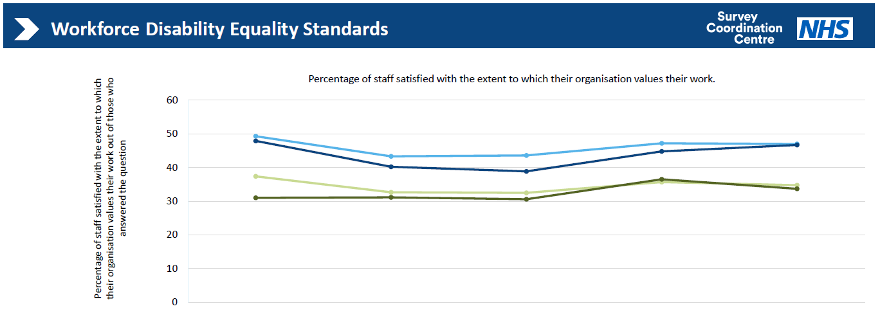
].
Staff group | 2020 | 2021 | 2022 | 2023 |  | 2024
Staff with a LTC or illness SWBH | 31.00% | 31.11% | 30.56% | 36.49% |  | 33.65%
Staff without a LTC or illness SWBH | 47.89% | 40.21% | 38.84% | 44.79% |  | 46.70%
Staff with a LTC or illness average | 37.36% | 32.62% | 32.46% | 35.66% |  | 34.73%
Staff without a LTC or illness average | 49.27% | 43.30% | 43.56% | 47.19% |  | 46.98%
Staff with a LTC or illness responses | 442 | 569 | 553 | 518 |  | 639
Staff without a LTC or Illness responses | 1892 | 1972 | 2052 | 1708 |  | 2043

Metric 8 - Percentage of staff with a long-lasting health condition or illness saying their employer has made reasonable adjustments to enable them to carry out work.
The percentage of staff with a long-term condition or illness reporting that their employer has made reasonable adjustments to support them in their work has improved from 68.94% to 71.94%. This represents a 2% percentage point improvement since the previous reporting year.
Table 8: Workforce Disability Equality Data for Metric 8 from 2020 to 2024.
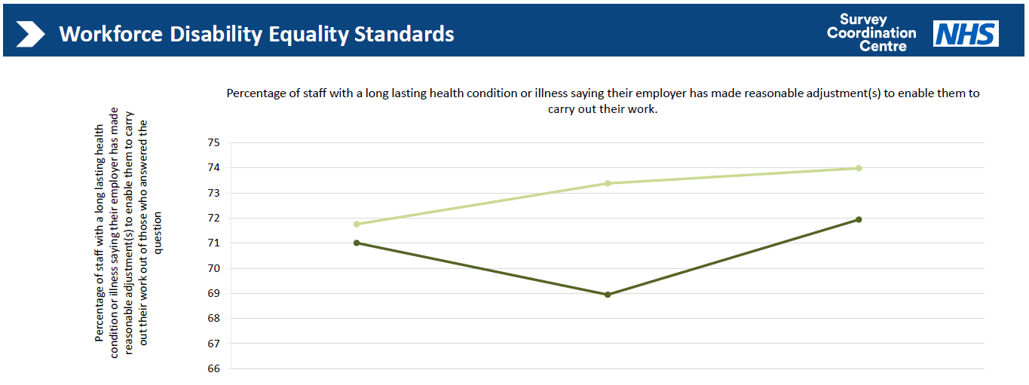

Staff group | 2022 | 2023 | 2024
Staff with a LTC or illness SWBH | 71.01% | 68.94% | 71.94%
Staff with a LTC or illness average | 71.76% | 73.38% | 73.98%
Staff with a LTC or illness responses | 338 | 322 | 392

Metric 9a – Staff engagement score (0-10)
The staff engagement score has fluctuated slightly over the past 5 years. There has been a positive upward trend for the indicator. In 2024, the engagement score is 6.3 compared to 6.2 in 2023. For staff without a long-term condition or illness, the engagement score was 6.87 in 2023 and has increased slightly in 2024 to 6.97.
Table 9:Workforce Disability Equality Data for Metric 8 from 2020 to 2024.

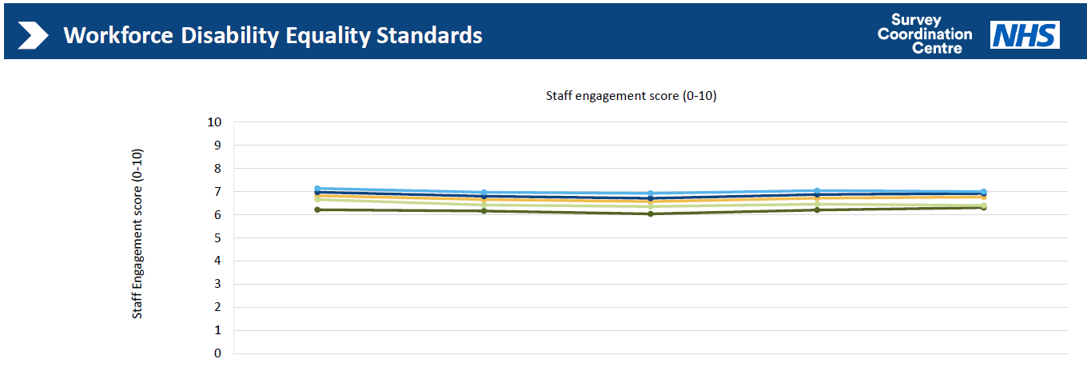

Staff group | 2020 | 2021 | 2022 | 2023 | 2024
Organisation average | 6.82 | 6.65 | 6.57 | 6.71 | 6.76
Staff with a LTC or illness SWBH | 6.21 | 6.16 | 6.03 | 6.2 | 6.3
Staff without a LTC or illness SWBH | 6.97 | 6.8 | 6.71 | 6.87 | 6.92
Staff with a LTC or illness average | 6.65 | 6.42 | 6.35 | 6.46 | 6.4
Staff without a LTC or illness average | 7.14 | 6.97 | 6.92 | 7.04 | 7
Staff with a LTC or illness responses | 446 | 572 | 555 | 518 | 641
Staff without a LTC or Illness responses | 1895 | 1978 | 2063 | 1709 | 2046

Metric 9b – How the organisation facilitates the voices of staff with disabilities
Over the past year, the Trust has made notable progress in enhancing the visibility and impact of the Disability & Long-Term Conditions Staff Network. The Network’s core activities have centred around raising awareness, promoting available support services, and creating a safe space for staff to share their lived experiences. These initiatives continue to play a vital role in advancing our commitment to creating a workplace where all staff feel valued, supported, and able to thrive.

We have maintained our collaborative efforts with the Electronic Staff Record (ESR) team to encourage staff to disclose or update their equality and diversity information. As a result, the disability disclosure rate has increased to 4.8%, up from 4.0% in the previous year. Additionally, the rate of non-disclosure has decreased by 2%. These improvements provide a more accurate understanding of our workforce and support more targeted and inclusive interventions.

In 2024, the Trust was successfully reassessed and achieved Level 2 status under the Disability Confident scheme, as evaluated by the Employers Network for Equality and Inclusion (enei). Furthermore, the Trust was awarded gold status in enei’s Talent Inclusion & Diversity Evaluation (TIDE) Mark—an important recognition of our continued progress and leadership in equality, diversity, and inclusion.

Metric 10 – Board representation
The representation of individuals with a long-term health condition or disability on the Board remains unchanged."

Conclusion
The Trust continues to make good progress with disability equality and is currently implementing the following programmes of work to progress disability equality.

Improving Support for Disabled Colleagues: Progress and Next Steps
In collaboration with the Disability and Long-term Conditions Network lead, a comprehensive set of actions has been established to enhance support for our disabled colleagues. The primary focus is on facilitating reasonable adjustments through improved awareness, education, and streamlined processes.
- Implementation of the Health Passport
The Health Passport initiative aims to enable constructive conversations between disabled colleagues and their managers regarding health needs and reasonable adjustments. A recent survey assessed current usage and potential areas for improvement. The findings are currently under review, with a planned launch targeted for Q3 2025.
- Development of a Reasonable Adjustments Framework
While the existing Attendance at Work policy outlines requirements for reasonable adjustments, it does not always apply, particularly where absence is not a factor or adjustments are needed for broader inclusivity reasons (e.g., menopause-related symptoms). To address this gap, a dedicated Reasonable Adjustments Framework is being developed. This framework will provide clear guidance to managers on legal obligations and best practices, supporting staff inclusively across a variety of scenarios. Development will be carried out in partnership with People Services, the Equality, Diversity & Inclusion (EDI) team, and relevant staff networks, with completion aimed for Q3 2025.
- Focus Groups to Identify Barriers and Solutions
To deepen understanding of challenges related to reasonable adjustments, focus groups involving key managers and staff will be facilitated by the Disability & Long-term Health Conditions Network, supported by the People Engagement & Experience team. Insights gained will inform tailored interventions designed to improve support and foster positive cultural change.
- ARC Leadership Training on Reasonable Adjustments
As part of the Wellbeing module within the ARC leadership development programme, targeted training on the requirements and implementation of reasonable adjustments for managers will be introduced. This training was launched in July 2025.
- Joint Briefing and Targeted Communications
Complementing the training efforts, concise and accessible briefing materials and communications will be developed to raise awareness of different disabilities and enhance understanding of reasonable adjustments. This initiative is being led by the Disability & Long-term Health Conditions Network.
- Centralised Oversight and Funding Pathways
Recognising delays in accessing funding through the Access to Work scheme, we are exploring options for centralised support of certain adjustments. This approach aims to identify alternative solutions that expedite access to necessary resources and mitigate funding-related challenges.

Summary / Next Steps:
This work represents a significant step toward embedding inclusive practices across the organisation. Key milestones are scheduled through Q3 2025, with cross-functional collaboration ensuring both compliance and culture change. Board oversight and support will be critical to sustaining progress and ensuring organisational accountability.

Looking ahead to 2025/26, the Trust People Committee in March agreed to focus on the delivery of the following People Priorities for 2025/26.

- Improve Staff Engagement Score
- Deliver sustained improvements across all NHS People Promises
- Increase Representational Leadership
- Implement national EDI high- impact actions
- Drive further improvements in the Trust’s WRES and WDES outcomes
- Optimise workforce productivity

These priorities are being delivered at 4 levels (Fig1) : (1) Leadership (2) Teams (3) Individuals and (4) Organisation wide:
- Leadership: Strengthen leadership capability and accountability.
- Teams: Build high performing, engaged teams.
- Individuals: Empower colleagues to own and shape their experience.
- Organisation-wide: Systematically embed improvements across policies, systems, and culture.
(Figure 2 )
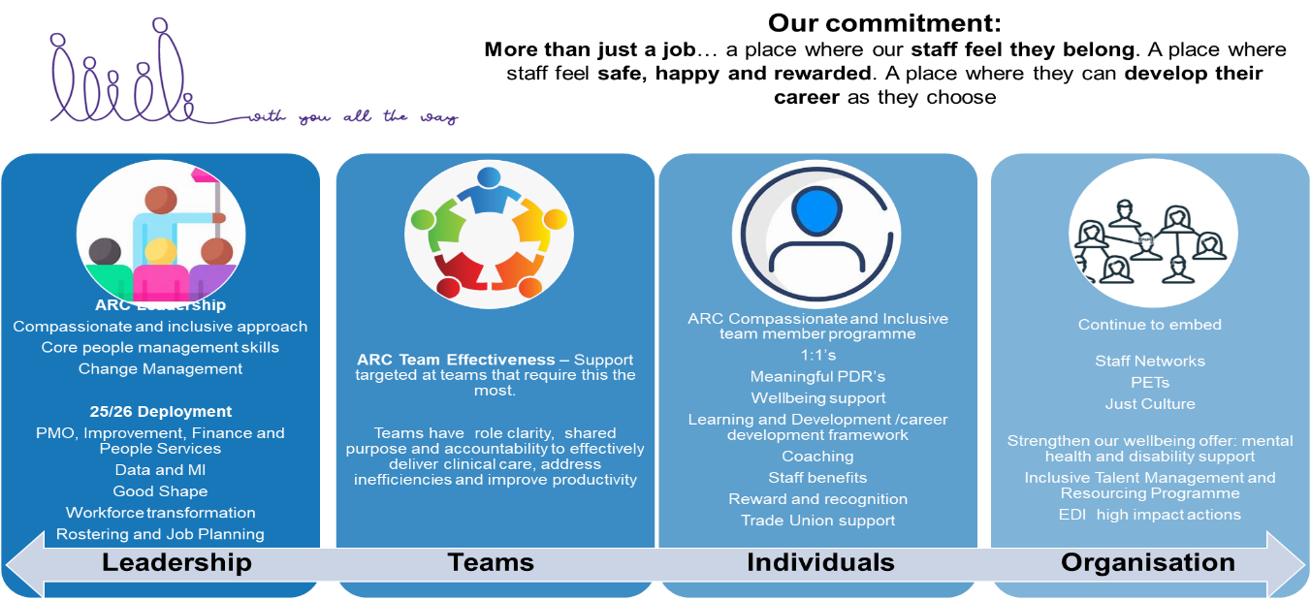

We will through this programme of work also continue to embed the following Four high-impact actions introduced in 2024 to drive further progress:
- Empower, equip, and enable Staff Networks
- Optimise the role and function of the EDI Team within the Trust
- Deliver and embed a robust framework for inclusive recruitment
- Launch a SWB Inclusive Talent Management Programme

