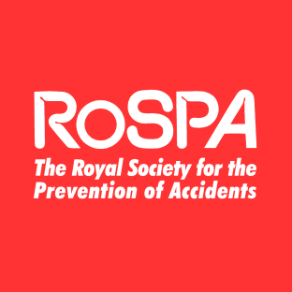
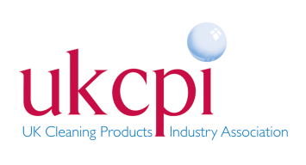
A Safety Checklist for Parents

TAKE ACTION TODAY, PUT THEM AWAY
A major Birmingham pilot programme to promote awareness and prevent accidents with household cleaning products

Cleaning Products | Yes No
Are all household cleaning products stored in a secure place out of the reach of children?

Where ever possible do you buy products in child resistant containers?

Do you always store cleaning products in their originals container?

Do you store food and household products separately?

Do you always read the label to find out how to use household products safely?

Do you always put the cap/tops back on and store products away immediately after use?

Do you know what to do if a household product is accidently ingested or spilt on the skin?

Medicines | Yes No
Are all medicines stored in a lockable cupboard out of the reach of children

Do you always store medicines in their original containers?

Do you throw away old medicines?

Do you know what to do if medicine is accidently ingested?

Carbon Monoxide | Yes No
Ensure that gas appliances and heaters are checked and serviced regularly
Garden | Yes No
Do you check plants to ensure that they are not poisonous or that they can irritate your skin
Are all garden and decorating products stored in a secure place out of the reach of children?
If you have answered ‘NO’ to any of the above please visit the home safety pages and Frequently Asked Questions section of RoSPA’s website at www.rospa.com for further information
REMEMBER:
- NEVER leave your child unsupervised
- NEVER mix cleaning products
- ALWAYS seek medical attention if medicine or a cleaning product is ingested or enters the eyes

